Project Planning Phase
Project Planning Template (Product Backlog, Sprint Planning, Stories, Story Points)
Date | 7 July 2026
Team ID | SWTID-2026-2247
Project Name | Emotion Detection and Learning Support Engine
Maximum Marks | 5 Marks

Product Backlog, Sprint Schedule, and Estimation (4 Marks)
The product backlog below breaks the Emotion Detection and Learning Support Engine into five sprints. Each sprint maps to one or two epics from the project roadmap, with user stories, story point estimates, and priority assigned so the team can plan capacity and sequence delivery.
Sprint-1 — Environment Setup
USN-1 As a developer, I can obtain a Gemini API key so the app can call the generative AI service. [1 pt | Priority: High]
USN-2 As a developer, I can install Python and create a virtual environment for isolated dependencies. [1 pt | Priority: High]
USN-3 As a developer, I can install all project dependencies from requirements.txt. [2 pt | Priority: High]
USN-4 As a developer, I can create a .env file to store configuration securely. [1 pt | Priority: Medium]
USN-5 As a developer, I can verify model and data directories exist and are accessible. [1 pt | Priority: Medium]
USN-6 As a developer, I can prepare a standardized project folder structure. [2 pt | Priority: Medium]
Sprint total: 8 story points
Sprint-2 — Kaggle Model Training
USN-7 As an ML engineer, I can set up a Kaggle notebook with GPU, dependencies, and data loading. [3 pt | Priority: High]
USN-8 As an ML engineer, I can preprocess and tokenize text data for both models. [3 pt | Priority: High]
USN-9 As an ML engineer, I can train a BiLSTM model for lightweight emotion classification. [5 pt | Priority: High]
USN-10 As an ML engineer, I can domain-adapt and fine-tune models on relevant data. [5 pt | Priority: Medium]
USN-11 As an ML engineer, I can fine-tune a BERT classifier with class weighting. [5 pt | Priority: High]
USN-12 As a developer, I can export trained models and integrate them locally. [3 pt | Priority: High]
Sprint total: 24 story points
Sprint-3 — Core Emotion Detection Pipeline
USN-13 As a developer, I can preprocess text and apply keyword-based enhancement. [2 pt | Priority: High]
USN-14 As a developer, I can run the BiLSTM classifier and get 5-class softmax scores. [3 pt | Priority: High]
USN-15 As a developer, I can run the BERT classifier with class weighting and keyword adjustments. [3 pt | Priority: High]
USN-16 As a user, I want mixed emotions (≥15% secondary score) detected in my input. [3 pt | Priority: High]
USN-17 As a developer, I can rely on a unified prediction schema across both models. [2 pt | Priority: Medium]
USN-18 As a developer, I can persist predictions to CSV with cached model loading. [2 pt | Priority: Medium]
Sprint total: 15 story points
Sprint-4 — AI Guidance Engine & UI Foundation
USN-19 As a user, I can provide field and problem context for prompt generation. [2 pt | Priority: High]
USN-20 As a user, I receive an empathetic, context-aware AI-generated response. [3 pt | Priority: High]
USN-21 As a user, I can regenerate a response and have it stay in sync with the UI. [3 pt | Priority: Medium]
USN-22 As a user, my session history is preserved and logged to CSV. [2 pt | Priority: Medium]
USN-23 As a user, I get a responsive layout with reliable session state management. [2 pt | Priority: High]
Sprint total: 12 story points
Sprint-5 — UI Completion & Testing
USN-24 As a user, I can view emotion analysis, model comparison, and visualizations. [3 pt | Priority: High]
USN-25 As a user, I get form validation and friendly error handling. [2 pt | Priority: Medium]
USN-26 As a user, I can explore an analytics dashboard with interactive charts. [3 pt | Priority: Medium]
USN-27 As a QA tester, I can validate the full UI flow end-to-end. [2 pt | Priority: High]
USN-28 As a developer, I can confirm the app is optimized and deployment-ready. [3 pt | Priority: High]
Sprint total: 13 story points
Project Tracker, Velocity & Burndown Chart (4 Marks)
The tracker below plans each sprint's duration, target dates, and story points so progress can be measured against the plan as sprints are executed.
Sprint-1: 8 story points planned, 6 Days (07 Jul 2026 → 12 Jul 2026)
Sprint-2: 24 story points planned, 6 Days (13 Jul 2026 → 18 Jul 2026)
Sprint-3: 15 story points planned, 6 Days (20 Jul 2026 → 25 Jul 2026)
Sprint-4: 12 story points planned, 6 Days (27 Jul 2026 → 01 Aug 2026)
Sprint-5: 13 story points planned, 6 Days (03 Aug 2026 → 08 Aug 2026)

Velocity:
Across the 5 planned sprints, the team estimates a total of 72 story points. With 6-day sprints, that gives an average velocity of 14.4 story points per sprint, or roughly 2.4 story points per day. Sprint-2 (Kaggle Model Training) is the heaviest sprint at 24 points, reflecting the time-intensive nature of data preprocessing and model fine-tuning.
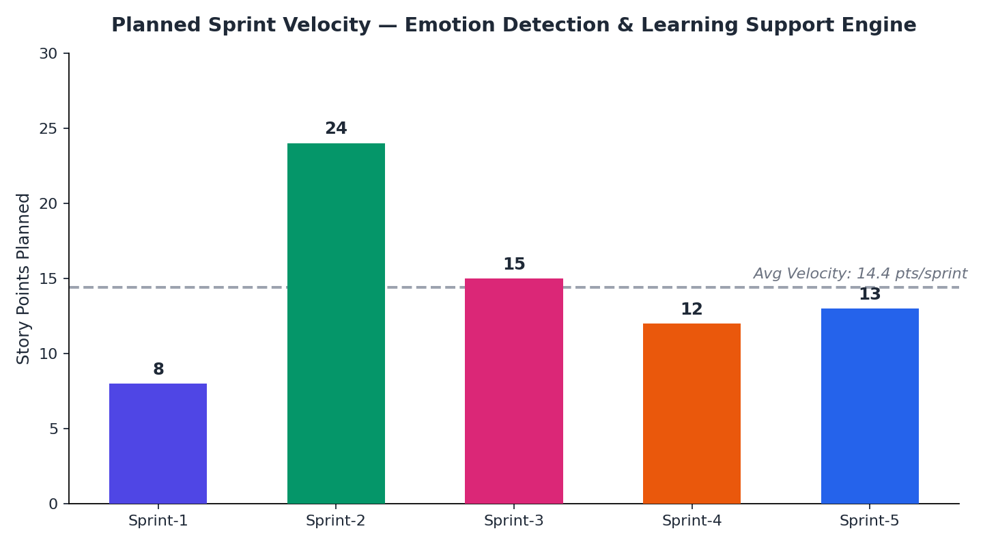
Burndown Chart:
A burndown chart shows remaining story points against time, making it easy to see whether the team is on track to complete the backlog within the planned sprints. The chart below plots the planned burndown for the Emotion Detection and Learning Support Engine against an ideal straight-line pace across all 5 sprints.
